Design and Analysis of Algorithms (CS206)

Assignment - 3

**U19CS012**

1. Given the following algorithms, answer the questions.

• Merge sort: Sorting Problem

Input: A Sequence of Unsorted ‘n’ numbers, **a1,a2,…,an**

Output: A Permutation (Reordering) (**a1’,a2’,…,an’**) of Input Sequence

such that **a1’≤ a2’≤ … ≤ an’**

1. Write a program to sort an array, *arr*, consisting *n* numbers using the divide and

conquer approach - Use only merge sort.

(1) The divide step should split the array into two (nearly) equal sub-arrays.

(2) The divide step should split the array into three (nearly) equal sub-arrays

1.1. (T) Write pseudocodes to design the algorithms for above mentioned computational problem. Both algorithms should sort the data by dividing them into two and three (nearly) equal sub-arrays respectively.

(1) The divide step should split the array into two (nearly) equal sub-arrays.

A.) MergeSort2 Function

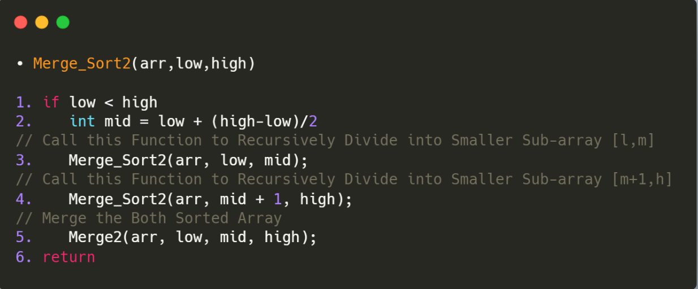

B.) Merge2 Function

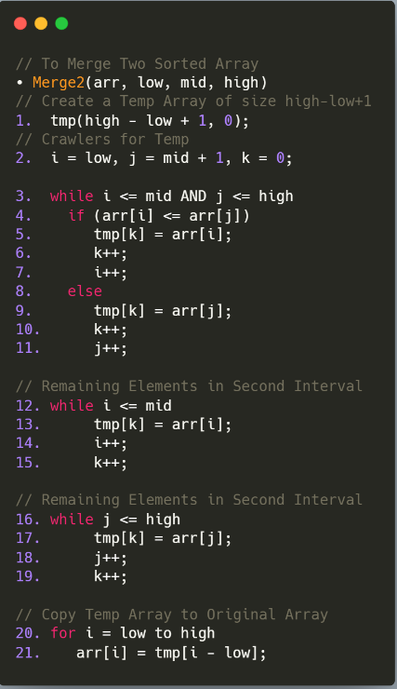

(2) The divide step should split the array into three (nearly) equal sub-arrays

A.) MergeSort3 Function

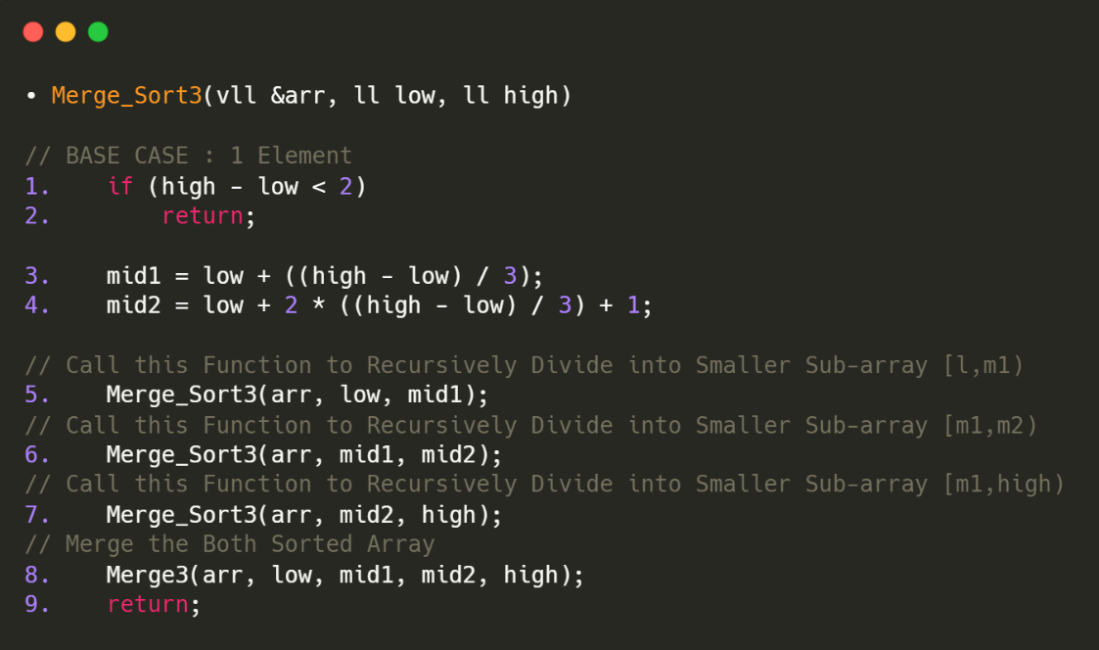

B.) Merge3 Function

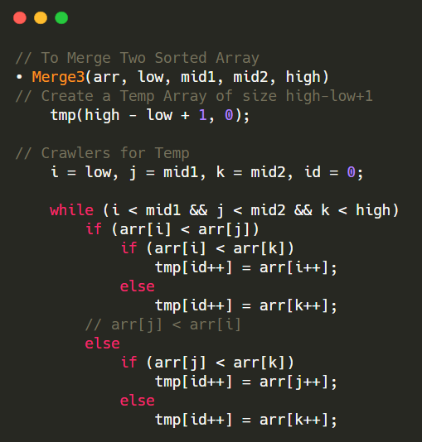

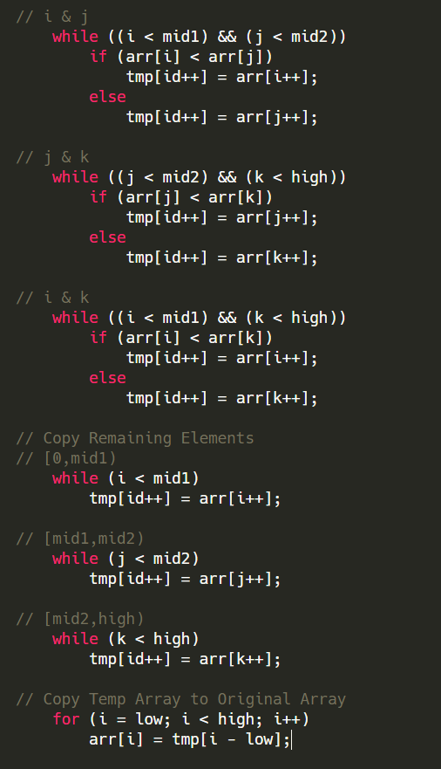

1.2. (T) Analyze the time complexity of both algorithms (split the array into two

and three sub-arrays) using the recursion tree method.

A.) Merge Sort Analysis by Dividing into Two Parts

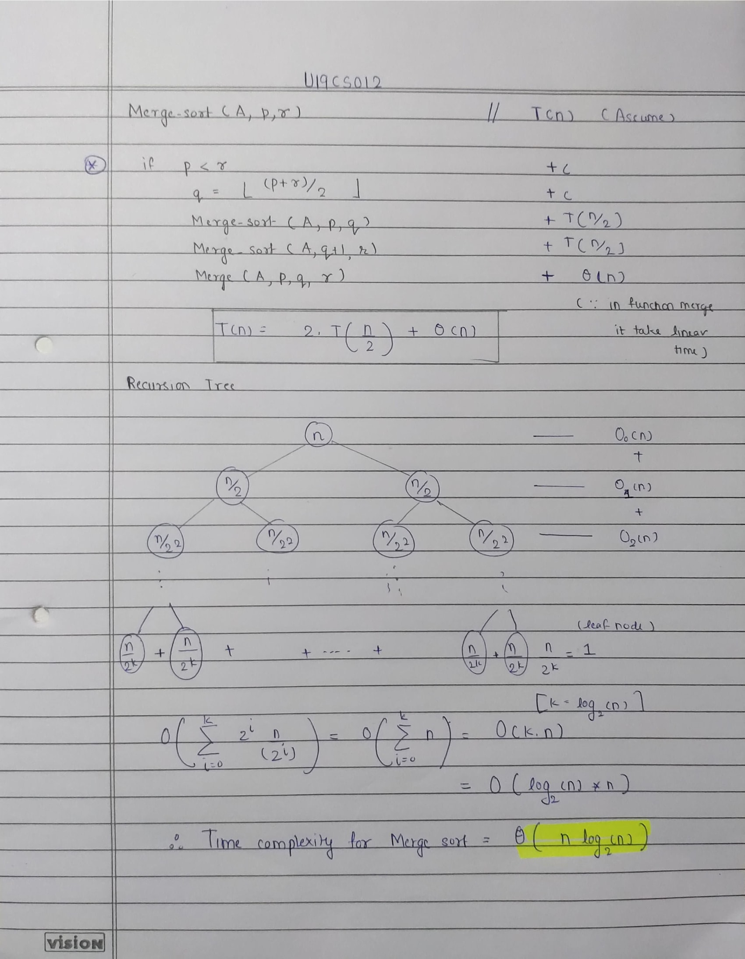

B.) Merge Sort Analysis by Dividing into Three Parts

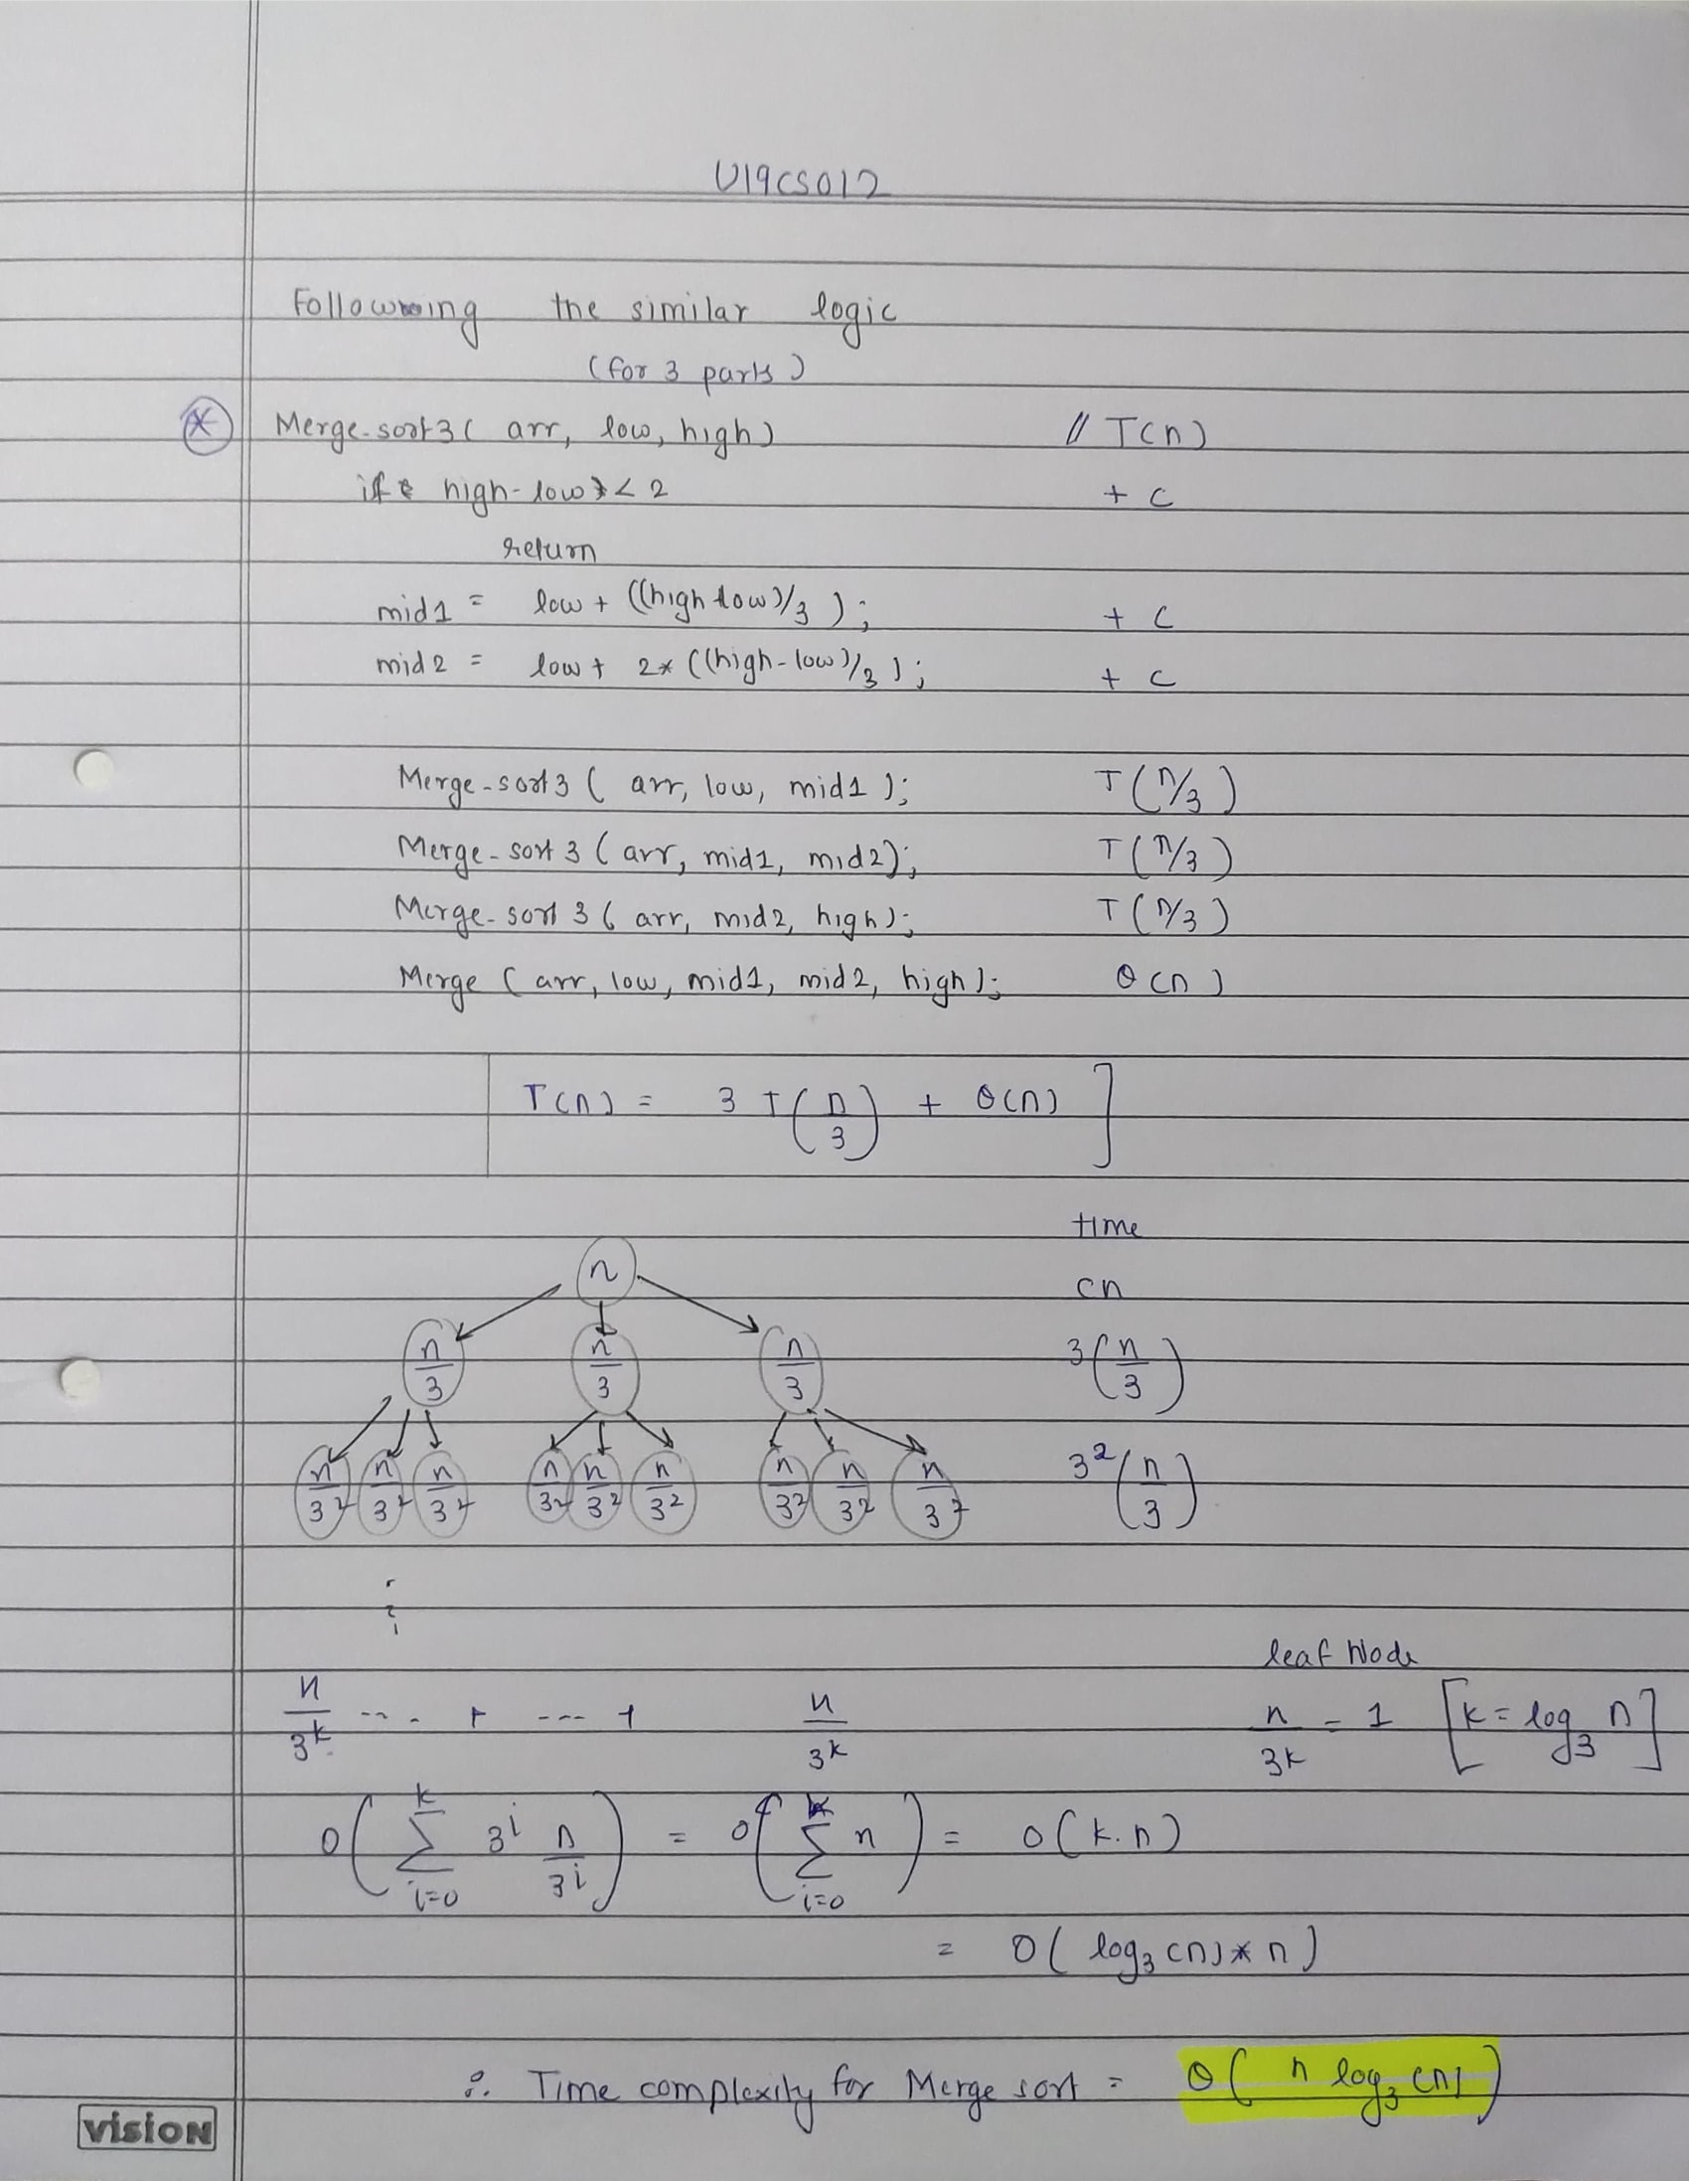

1.3. (L) Provide the details of Hardware/Software you used to implement algorithms and to measure the time.

Hardware Details of My Laptop:

|  |  |
| --- | --- |
| PARAMETER | LAPTOP CONFIGURATION |
| Operating System | Microsoft Windows **10** .0.19042 |
| Processor | Intel(R) Core(TM) i5-10210U [Core **i5 10th Gen**] |
| CPU | **1.60GHz**, 2112 Mhz, **4** Core(s), 8 Logical Processor(s) |
| System Type | x64-based PC [**64 Bit**] |
| RAM | **8.00** GB |
| Hard Drive/SSD | 512 GB **SSD** |

Software Used:

|  |  |
| --- | --- |
| PARAMETER | LAPTOP CONFIGURATION |
| Code Editor | **Visual Studio** Code [Version 1.52] |
| Compiler | gcc (MinGW.org **GCC-8.2.0-5**) 8.2.0 |
| Time | Measured using **chrono** Library in C++ |
| Programming Language Used | **C++** |

1.4. (L) Submit the code (complete programs).

A.) ***Merge Sort Program*** by Dividing into **Two Parts**

*// HEADERS AND NAMESPACE*

*#include* <bits/stdc++.h>

*// INSTEAD OF ALL THESE*

*#include* <iostream>

*// For Creating File*

*#include* <fstream>

*#include* <vector>

*// For set - precision*

*#include* <iomanip>

*// For Time Calculation*

*#include* <chrono>

*// For File Name and Output File Name*

*#include* <string>

using namespace std;

using namespace std::chrono;

*// COMMONLY USED TYPES*

typedef long long ll;

typedef vector<ll> vll;

*// Basic Algorithm Implementation of Merge Sort*

*// To Merge Two Sorted Array*

void merge(vll &arr, ll low, ll mid, ll high)

{

*// Create a Temp Array*

    vll tmp(high - low + 1, 0);

*// Crawlers for Temp*

    ll i = low, j = mid + 1, k = 0;

*while* (i <= mid && j <= high)

    {

*if* (arr[i] <= arr[j])

        {

            tmp[k] = arr[i];

            k++;

            i++;

        }

*else*

        {

            tmp[k] = arr[j];

            k++;

            j++;

        }

    }

*// Remaining Elements in Second Interval*

*while* (i <= mid)

    {

        tmp[k] = arr[i];

        i++;

        k++;

    }

*// Remaining Elements in Second Interval*

*while* (j <= high)

    {

        tmp[k] = arr[j];

        j++;

        k++;

    }

*// Copy Temp Array to Original Array*

*for* (i = low; i <= high; i++)

    {

        arr[i] = tmp[i - low];

    }

}

*// Real Merge Sort Function*

void merge_sort(vll &arr, ll low, ll high)

{

*if* (low < high)

    {

        ll mid = low + (high - low) / 2;*// To Avoid Overflow*

*// Call this Function to Recursively Divide into Smaller Sub-array [l,m]*

        merge_sort(arr, low, mid);

*// Call this Function to Recursively Divide into Smaller Sub-array [m+1,h]*

        merge_sort(arr, mid + 1, high);

*// Merge the Both Sorted Array*

        merge(arr, low, mid, high);

    }

*return*;

}

int main()

{

*// For Read & Write from "Input File" and  Return Output to "Output" File*

    freopen("output.txt", "w", stdout);

*// EDIT THIS FILE NUMBER , LIMIT and Number of Times File Runs*

    int file_no = 1;

    int limit = 10;

    int each_file_runs = 2;

*for* (; file_no <= limit; file_no++)

    {

        string inp_file = "File";

        string num = to_string(file_no);

        string ext = ".txt";

        inp_file += num;

        inp_file += ext;

        ifstream File;

        File.open(inp_file);

        vector<ll> arr;

        ll number, idx = 0;

*while* (!File.eof())

        {

            File >> number;

            arr.push_back(number);

        }

        ll Best_Duration = 0, Worst_Duration = 0, Average_Duration = 0;

        auto start = high_resolution_clock::now();

        auto end = high_resolution_clock::now();

        auto time_taken = duration_cast<nanoseconds>(end - start);

        ll n1 = arr.size();

*for* (int f = 0; f < each_file_runs; f++)

        {

*// -------------------------AVERAGE CASE [O(n^2)]-----------------------------*

            start = high_resolution_clock::now();

*// Function Here*

            merge_sort(arr, 0, arr.size() - 1);

*// Function Ends here*

            end = high_resolution_clock::now();

            time_taken = duration_cast<nanoseconds>(end - start);

            Average_Duration += time_taken.count();

*// -------------------------BEST CASE [0(n^2)]-----------------------------*

*// The Array is Already Sorted from Average Case, So it Becomes out Best Case*

*// sort(arr.begin(), arr.end());*

            start = high_resolution_clock::now();

*// Function Here*

            merge_sort(arr, 0, arr.size() - 1);

*// Function Ends here*

            end = high_resolution_clock::now();

            time_taken = duration_cast<nanoseconds>(end - start);

            Best_Duration += time_taken.count();

*// -------------------------WORST CASE [0(n^2)]-----------------------------*

*// This will Reverse the Sorted Array, Therfore we will Get the Worst Case*

            reverse(arr.begin(), arr.end());

*// sort(arr.begin(), arr.end(), greater<ll>());*

            start = high_resolution_clock::now();

*// Function Here*

            merge_sort(arr, 0, arr.size() - 1);

*// Function Ends here*

            end = high_resolution_clock::now();

            time_taken = duration_cast<nanoseconds>(end - start);

            Worst_Duration += time_taken.count();

        }

        cout << "--------------------------------------------------------" << endl;

        cout << inp_file << endl;

        cout << "AVERAGE CASE : ";

        double avg = (double)Average_Duration / (double)each_file_runs;

        avg *= 1e-9;

        cout << fixed << avg << setprecision(9);

        cout << " seconds" << endl;

        cout << "BEST CASE    : ";

        double best = (double)Best_Duration / (double)each_file_runs;

        best *= 1e-9;

        cout << fixed << best << setprecision(9);

        cout << " seconds" << endl;

        cout << "WORST CASE   : ";

        double worst = (double)Worst_Duration / (double)each_file_runs;

        worst *= 1e-9;

        cout << fixed << worst << setprecision(9);

        cout << " seconds" << endl;

    }

*return* 0;

}

B.) ***Merge Sort Program*** by Dividing into **Three Parts**

*// HEADERS AND NAMESPACE*

*#include* <bits/stdc++.h>

*// INSTEAD OF ALL THESE*

*#include* <iostream>

*// For Creating File*

*#include* <fstream>

*#include* <vector>

*// For set - precision*

*#include* <iomanip>

*// For Time Calculation*

*#include* <chrono>

*// For File Name and Output File Name*

*#include* <string>

using namespace std;

using namespace std::chrono;

*// COMMONLY USED TYPES*

typedef long long ll;

typedef vector<ll> vll;

*// Basic Algorithm Implementation of Merge Sort*

*// To Merge Two Sorted Array*

void merge(vll &arr, ll low, ll mid1, ll mid2, ll high)

{

*// Create a Temp Array*

    vll tmp(high - low + 1, 0);

*// Crawlers for Temp*

    ll i = low, j = mid1, k = mid2, id = 0;

*while* (i < mid1 && j < mid2 && k < high)

    {

*if* (arr[i] < arr[j])

        {

*if* (arr[i] < arr[k])

            {

                tmp[id++] = arr[i++];

            }

*else*

            {

                tmp[id++] = arr[k++];

            }

        }

*// arr[j] < arr[i]*

*else*

        {

*if* (arr[j] < arr[k])

            {

                tmp[id++] = arr[j++];

            }

*else*

            {

                tmp[id++] = arr[k++];

            }

        }

    }

*// i & j*

*while* ((i < mid1) && (j < mid2))

    {

*if* (arr[i] < arr[j])

        {

            tmp[id++] = arr[i++];

        }

*else*

        {

            tmp[id++] = arr[j++];

        }

    }

*// j & k*

*while* ((j < mid2) && (k < high))

    {

*if* (arr[j] < arr[k])

        {

            tmp[id++] = arr[j++];

        }

*else*

        {

            tmp[id++] = arr[k++];

        }

    }

*// i & k*

*while* ((i < mid1) && (k < high))

    {

*if* (arr[i] < arr[k])

        {

            tmp[id++] = arr[i++];

        }

*else*

        {

            tmp[id++] = arr[k++];

        }

    }

*// Copy Remaining Elements*

*// [0,mid1)*

*while* (i < mid1)

    {

        tmp[id++] = arr[i++];

    }

*// [mid1,mid2)*

*while* (j < mid2)

    {

        tmp[id++] = arr[j++];

    }

*// [mid2,high)*

*while* (k < high)

    {

        tmp[id++] = arr[k++];

    }

*// Copy Temp Array to Original Array*

*for* (i = low; i < high; i++)

    {

        arr[i] = tmp[i - low];

    }

}

*// Real Merge Sort Function*

void merge_sort(vll &arr, ll low, ll high)

{

*// BASE CASE : 1 Element*

*if* (high - low < 2)

    {

*return*;

    }

    ll mid1 = low + ((high - low) / 3);

    ll mid2 = low + 2 * ((high - low) / 3) + 1;

*// Call this Function to Recursively Divide into Smaller Sub-array [l,m1)*

    merge_sort(arr, low, mid1);

*// Call this Function to Recursively Divide into Smaller Sub-array [m1,m2)*

    merge_sort(arr, mid1, mid2);

*// Call this Function to Recursively Divide into Smaller Sub-array [m1,high)*

    merge_sort(arr, mid2, high);

*// Merge the Both Sorted Array*

    merge(arr, low, mid1, mid2, high);

*return*;

}

int main()

{

*// For Read & Write from "Input File" and  Return Output to "Output" File*

    freopen("output.txt", "w", stdout);

*// EDIT THIS FILE NUMBER , LIMIT and Number of Times File Runs*

    int file_no = 1;

    int limit = 10;

    int each_file_runs = 3;

*for* (; file_no <= limit; file_no++)

    {

        string inp_file = "File";

        string num = to_string(file_no);

        string ext = ".txt";

        inp_file += num;

        inp_file += ext;

        ifstream File;

        File.open(inp_file);

        vector<ll> arr;

        ll number, idx = 0;

*while* (!File.eof())

        {

            File >> number;

            arr.push_back(number);

        }

        ll Best_Duration = 0, Worst_Duration = 0, Average_Duration = 0;

        auto start = high_resolution_clock::now();

        auto end = high_resolution_clock::now();

        auto time_taken = duration_cast<nanoseconds>(end - start);

        ll n1 = arr.size();

*for* (int f = 0; f < each_file_runs; f++)

        {

*// -------------------------AVERAGE CASE [O(n^2)]-----------------------------*

            start = high_resolution_clock::now();

*// Function Here*

            merge_sort(arr, 0, arr.size());

*// Function Ends here*

            end = high_resolution_clock::now();

            time_taken = duration_cast<nanoseconds>(end - start);

            Average_Duration += time_taken.count();

*// -------------------------BEST CASE [0(n^2)]-----------------------------*

*// The Array is Already Sorted from Average Case, So it Becomes out Best Case*

*// sort(arr.begin(), arr.end());*

            start = high_resolution_clock::now();

*// Function Here*

            merge_sort(arr, 0, arr.size() - 1);

*// Function Ends here*

            end = high_resolution_clock::now();

            time_taken = duration_cast<nanoseconds>(end - start);

            Best_Duration += time_taken.count();

*// -------------------------WORST CASE [0(n^2)]-----------------------------*

*// This will Reverse the Sorted Array, Therfore we will Get the Worst Case*

            reverse(arr.begin(), arr.end());

*// sort(arr.begin(), arr.end(), greater<ll>());*

            start = high_resolution_clock::now();

*// Function Here*

            merge_sort(arr, 0, arr.size() - 1);

*// Function Ends here*

            end = high_resolution_clock::now();

            time_taken = duration_cast<nanoseconds>(end - start);

            Worst_Duration += time_taken.count();

        }

        cout << "--------------------------------------------------------" << endl;

        cout << inp_file << endl;

        cout << "AVERAGE CASE : ";

        double avg = (double)Average_Duration / (double)each_file_runs;

        avg *= 1e-9;

        cout << fixed << avg << setprecision(9);

        cout << " seconds" << endl;

        cout << "BEST CASE    : ";

        double best = (double)Best_Duration / (double)each_file_runs;

        best *= 1e-9;

        cout << fixed << best << setprecision(9);

        cout << " seconds" << endl;

        cout << "WORST CASE   : ";

        double worst = (double)Worst_Duration / (double)each_file_runs;

        worst *= 1e-9;

        cout << fixed << worst << setprecision(9);

        cout << " seconds" << endl;

    }

*return* 0;

}

1.5. (L) Measure the best-case time, average-case time and worst-case time of the

above two algorithms for all ten files (Assignment 1). Plot a graph.

A.) ***Merge Sort Program*** by Dividing into **Two Parts**

|  |  |  |  |  |
| --- | --- | --- | --- | --- |
| FILE | No. of Elements | BEST CASE  [in sec] | AVERAGE CASE [in sec] | WORST CASE [in sec] |
| 1 | 1024 = 2^10 | 0.000000000 | 0.000519000 | 0.000000000 |
| 2 | 4096 = 2^12 | 0.003997500 | 0.008046500 | 0.003997500 |
| 3 | 16384 = 2^14 | 0.017086500 | 0.017533500 | 0.017251500 |
| 4 | 65536 = 2^16 | 0.037438500 | 0.043737500 | 0.042738500 |
| 5 | 262144 = 2^18 | 0.154819000 | 0.198323000 | 0.147636500 |
| 6 | 1048576 = 2^20 | 0.634084000 | 0.711899500 | 0.616180000 |
| 7 | 2097152 = 2^21 | 1.255310000 | 1.427379000 | 1.311771000 |
| 8 | 4194304 = 2^22 | 2.629683500 | 2.973717500 | 2.677120500 |
| 9 | 8388608 = 2^23 | 5.407570500 | 6.219963500 | 5.513057500 |
| 10 | 16777216 = 2^24 | 11.222652500 | 12.724297000 | 11.212041500 |

*Worst Case = Reverse Sorted Array

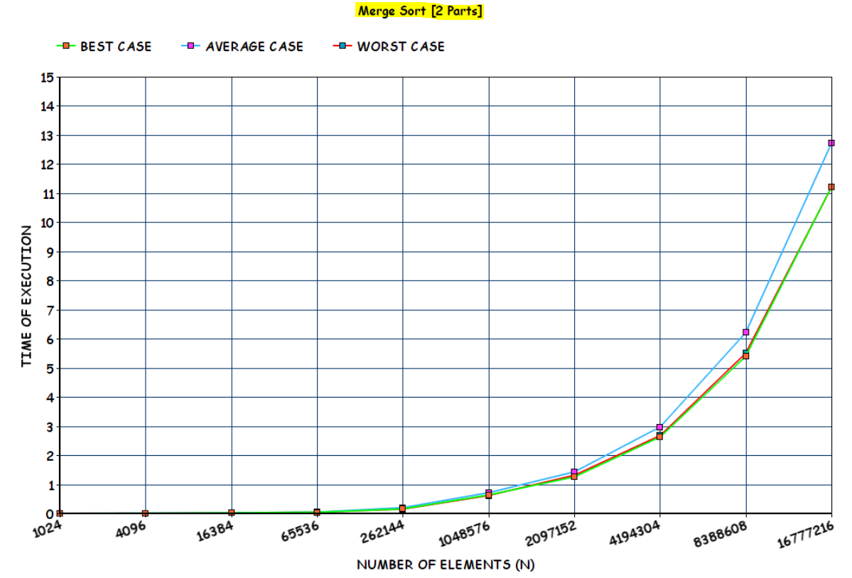

B.) ***Merge Sort Program*** by Dividing into **Three Parts**

|  |  |  |  |  |
| --- | --- | --- | --- | --- |
| FILE | No. of Elements | BEST CASE  [in sec] | AVERAGE CASE [in sec] | WORST CASE [in sec] |
| 1 | 1024 = 2^10 | 0.000000000 | 0.000332 | 0.001713000 |
| 2 | 4096 = 2^12 | 0.003036000 | 0.002839667 | 0.001595667 |
| 3 | 16384 = 2^14 | 0.003331667 | 0.007095667 | 0.010413333 |
| 4 | 65536 = 2^16 | 0.024336000 | 0.030064667 | 0.025325667 |
| 5 | 262144 = 2^18 | 0.105656333 | 0.126667667 | 0.111899000 |
| 6 | 1048576 = 2^20 | 0.477917333 | 0.528992333 | 0.476208667 |
| 7 | 2097152 = 2^21 | 1.054969667 | 0.936536667 | 0.931854000 |
| 8 | 4194304 = 2^22 | 2.252637667 | 2.009962000 | 1.972199000 |
| 9 | 8388608 = 2^23 | 3.994126333 | 4.524697667 | 3.966805333 |
| 10 | 16777216 = 2^24 | 8.216317333 | 9.190697000 | 8.110807000 |

*Worst Case = Reverse Sorted Array

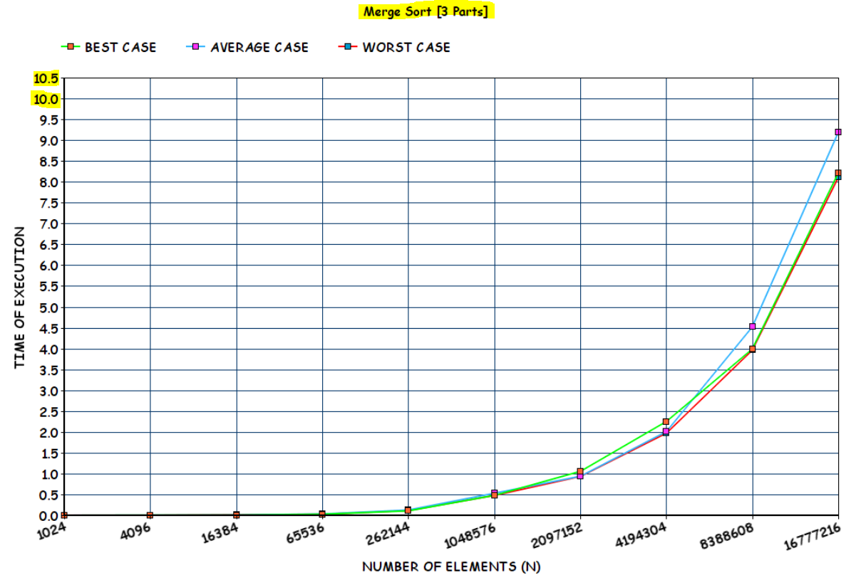

1.7. (L) Compare the average-case performance of bubble sort, selection sort, insertion sort, and merge sort for all ten files. Plot a graph.

AVERAGE CASE

|  |  |  |  |  |  |
| --- | --- | --- | --- | --- | --- |
| File | No. Of Elements | Bubble Sort | Selection Sort | Insertion Sort | Merge Sort |
| 1 | 2^10 | 0.01099400 | 0.002992000 | 0.000000000 | 0.000519000 |
| 2 | 2^12 | 0.111313000 | 0.050864000 | 0.038989000 | 0.008046500 |
| 3 | 2^14 | 1.501978000 | 0.669212000 | 0.345732500 | 0.017533500 |
| 4 | 2^16 | 24.017980000 | 11.059123000 | 4.971833000 | 0.043737500 |
| 5 | 2^18 | 487.501293000 | 174.081319000 | 78.119213000 | 0.198323000 |

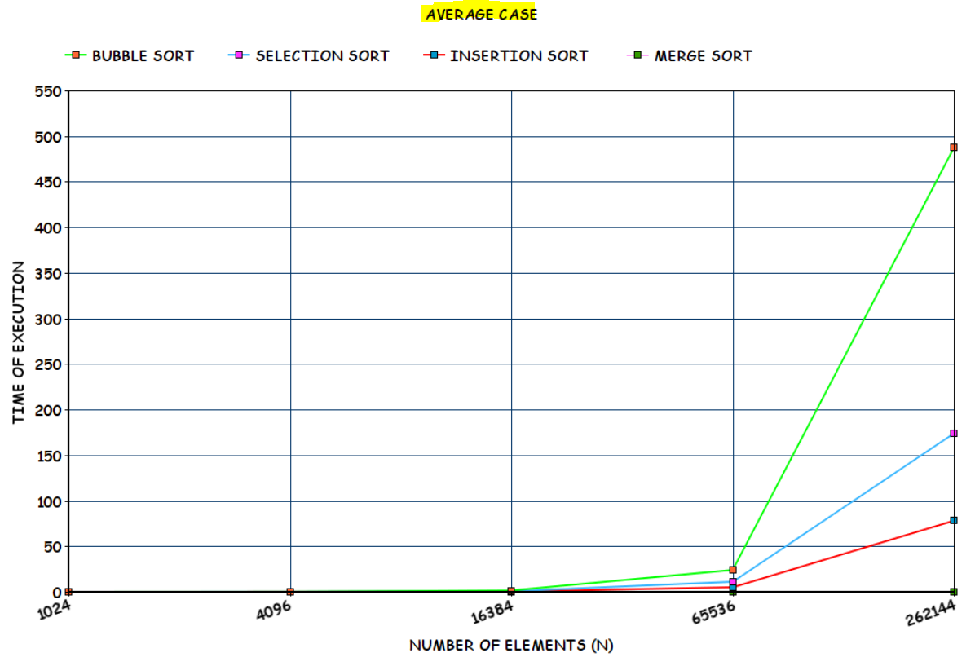

1.6. (L) Compare the best-case performance of bubble sort, selection sort, insertion sort, and merge sort for all ten files. Plot a graph.

BEST CASE

|  |  |  |  |  |  |
| --- | --- | --- | --- | --- | --- |
| File | No. Of Elements | Bubble Sort | Selection Sort | Insertion Sort | Merge Sort |
| 1 | 2^10 | 0.008177500 | 0.001993000 | 0.000000000 | 0.000000000 |
| 2 | 2^12 | 0.057657500 | 0.048870000 | 0.000000000 | 0.003997500 |
| 3 | 2^14 | 0.913967500 | 0.667217000 | 0.005000000 | 0.017086500 |
| 4 | 2^16 | 14.563756500 | 10.864665000 | 0.000000000 | 0.037438500 |
| 5 | 2^18 | 483.525254500 | 172.253910000 | 0.001998500 | 0.154819000 |

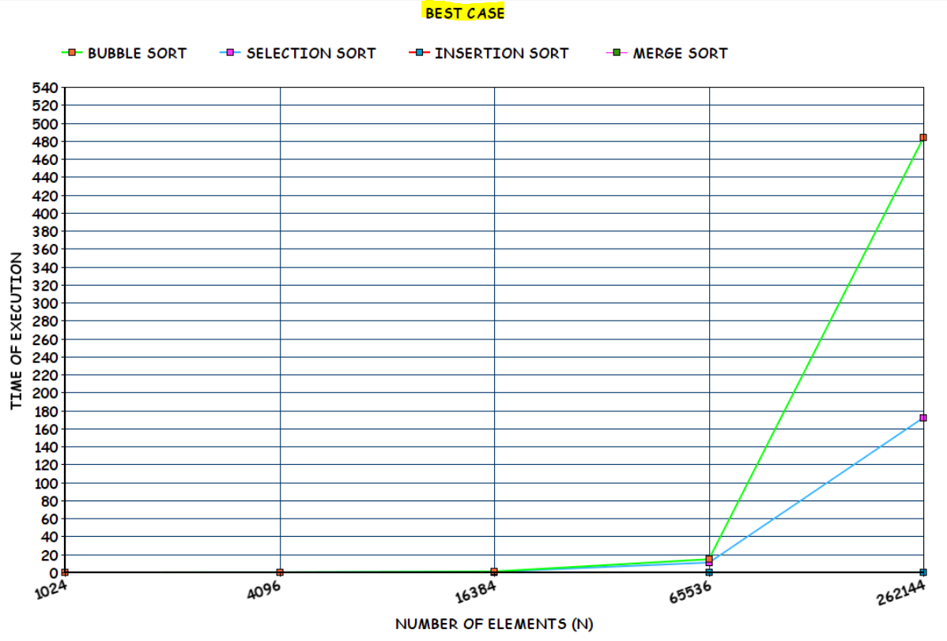

1.8. (L) Compare the worst-case performance of bubble sort, selection sort, insertion sort, and merge sort for all ten files. Plot a graph.

WORST CASE

|  |  |  |  |  |  |
| --- | --- | --- | --- | --- | --- |
| File | No. Of Elements | Bubble Sort | Selection Sort | Insertion Sort | Merge Sort  [Rev Sort] |
| 1 | 2^10 | 0.014323500 | 0.003026000 | 0.010075500 | 0.000000000 |
| 2 | 2^12 | 0.142320000 | 0.045876000 | 0.086874000 | 0.003997500 |
| 3 | 2^14 | 2.449665000 | 0.743014000 | 1.208551500 | 0.017251500 |
| 4 | 2^16 | 37.231916500 | 13.791273000 | 18.156971000 | 0.042738500 |
| 5 | 2^18 | 571.021661500 | 248.630703000 | 289.277434500 | 0.147636500 |

After File 5 Onwards, It would take a Minimum of 2 hrs for Each File Execution.

So Avoided Executing for Rest of the Files.

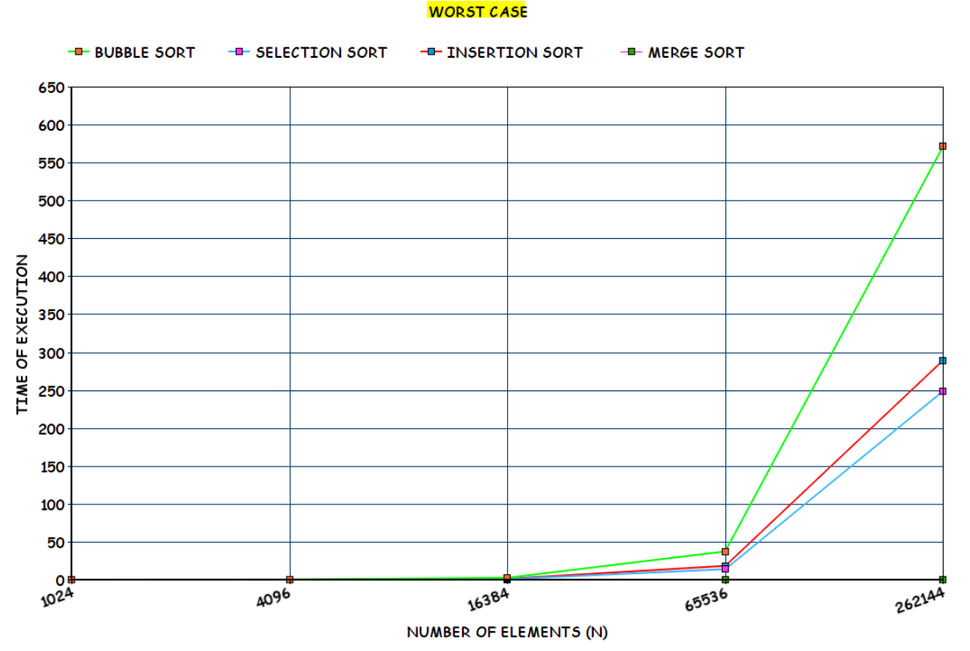

Note: *Real Worst Case is Calculated in Following Manner:*

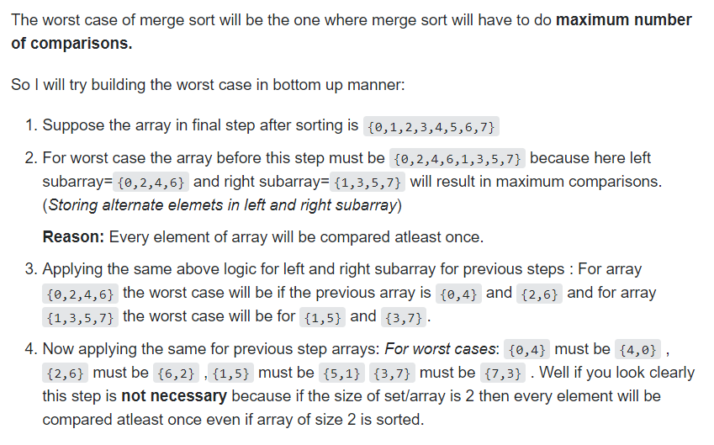

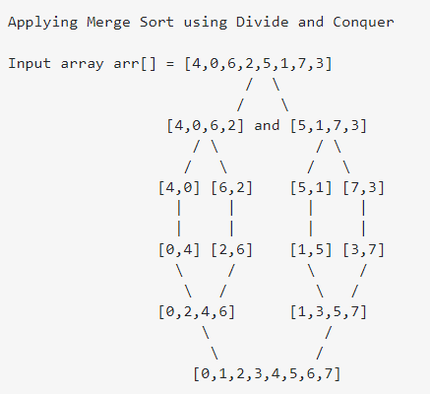

**MERGE SORT ALL CASE [THEORATICAL CALCULATION]**

|  |  |  |  |
| --- | --- | --- | --- |
| FILE | NUMBER OF ELEMENTS | NO OF OPERATIONS  O(N*LOG2(N)) | APPROX TIME TAKEN [OP/10^8] |
| FILE 1 | 1024 = 2^10 | 1024*10 | 0.0001024 |
| FILE 2 | 4096 = 2^12 | 4096*12 | 0.00049152 |
| FILE 3 | 16384 = 2^14 | 16384*14 | 0.00229376 |
| FILE 4 | 65536 = 2^16 | 65536*16 | 0.01048576 |
| FILE 5 | 262144 = 2^18 | 262144*18 | 0.04718592 |
| FILE 6 | 1048576 = 2^20 | 1048576*20 | 0.20971520 |
| FILE 7 | 2097152 = 2^21 | 2097152*21 | 0.44040192 |
| FILE 8 | 4194304 = 2^22 | 4194304*22 | 0.92274688 |
| FILE 9 | 8388608 = 2^23 | 8388608*23 | 1.92937984 |
| FILE 10 | 16777216 = 2^24 | 16777216*24 | 4.02653184 |

**For Bubble Sort, Selection Sort and Insertion Sort.**

**BEST CASE [THEORATICAL CALCULATION]**

|  |  |  |  |
| --- | --- | --- | --- |
| FILE | NUMBER OF ELEMENTS | NO OF OPERATIONS  [CASE] = O(N) | APPROX TIME TAKEN [OP/10^8] |
| FILE 1 | 1024 = 2^10 | 1024 | 0.00001024 |
| FILE 2 | 4096 = 2^12 | 4096 | 0.00004096 |
| FILE 3 | 16384 = 2^14 | 16384 | 0.00016384 |
| FILE 4 | 65536 = 2^16 | 65536 | 0.00065536 |
| FILE 5 | 262144 = 2^18 | 262144 | 0.00262144 |
| FILE 6 | 1048576 = 2^20 | 1048576 | 0.01048576 |
| FILE 7 | 2097152 = 2^21 | 2097152 | 0.02097152 |
| FILE 8 | 4194304 = 2^22 | 4194304 | 0.04194304 |
| FILE 9 | 8388608 = 2^23 | 8388608 | 0.08388608 |
| FILE 10 | 16777216 = 2^24 | 16777216 | 0.16777216 |

**WORST/AVERAGE CASE [THEORATICAL CALCULATION]**

|  |  |  |  |
| --- | --- | --- | --- |
| FILE | NUMBER OF ELEMENTS | NO OF OPERATIONS  [CASE] = O(N^2) | APPROX TIME TAKEN [OP/10^8] |
| FILE 1 | 1024 = 2^10 | 2^20 | 0.0104 seconds  = 0.01 sec |
| FILE 2 | 4096 = 2^12 | 2^24 | 0.167 seconds  = 0.16 sec |
| FILE 3 | 16384 = 2^14 | 2^28 | 2.684 seconds  = 2.6 sec |
| FILE 4 | 65536 = 2^16 | 2^32 | 43 seconds  = 43 sec |
| FILE 5 | 262144 = 2^18 | 2^36 | 687 seconds  = 11 mins |
| FILE 6 | 1048576 = 2^20 | 2^40 | 10995 seconds  = 3 hrs 3 mins |
| FILE 7 | 2097152 = 2^21 | 2^42 | 43980 seconds  = 12 hrs 13 mins |
| FILE 8 | 4194304 = 2^22 | 2^44 | 175922 seconds  = 2 days 52 hrs 2 mins |
| FILE 9 | 8388608 = 2^23 | 2^46 | 703687 seconds  = 8 days 3 hrs 28 mins |
| FILE 10 | 16777216 = 2^24 | 2^48 | 2814750 seconds  = 32 days 13 hrs 52 mins |

CONCLUSION:

***Bubble sort****: repeatedly compare neighbor pairs and swap if necessary.*

***Selection sort:*** *repeatedly pick the smallest element to append to the result.*

***Insertion sort****: repeatedly add new element to the sorted result.*

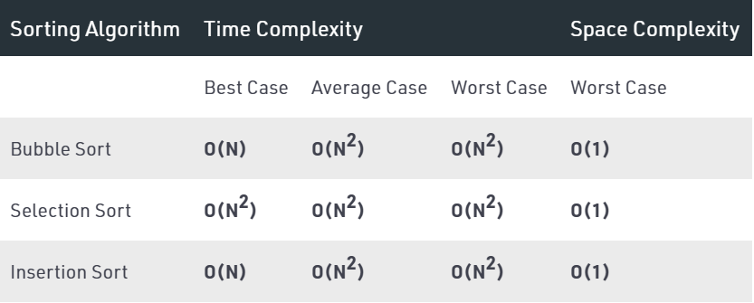

***Merge Sort:***

*1.) If it is only one element in the list it is already sorted, return.*

*2.)* ***Divide*** *the list recursively into two halves until it can no more be divided.*

*3.)* ***Merge*** *the smaller lists into new list in sorted order.*

* *Merge Sort is useful for* ***sorting linked lists.***
* *Merge Sort is a* ***stable sort*** *which means that the same element in an array maintain their original positions with respect to each other.*
* *Overall time complexity of Merge sort is O(nLogn).*

*It is more efficient as it is in worst case also the runtime is O(nlogn)*

* *The space complexity of Merge sort is O(n). [Not In-Place]*
* *This means that this algorithm takes a* ***lot of space*** *and may slower down operations for the last data sets.*

**SUBMITTED BY:**

**U19CS012**

**BHAGYA VINOD RANA**